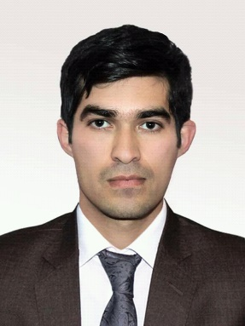

Experiences

Worked at badakhshan appeal court as trainee by coopration of giz and badakhshan university from augest—december 2018.

Worked at sehat Andishan CO LTD as a admin and finance manager in maine office Kabul from22 December 2018 to21 december 2020

Working at NSIA from 21 december2020 up to now.as quality control in dasht barchi, branch.

Courses and Seminars Attended

* Finished English and mathematical at during high school.
* Attended and Finished a lot of seminars at during of university.

About me

I was borne in 1995, honesty is my most important characteristic which is need for most jobs and relations to have it. In my idea everything is possible in the world and in our life, it’s important what we want and what’s our passion, just have a passion and do it.

Age:27

f/name: malabai

marital status: single

school percentage: 99.9%

**university percentage: 91.01**

Education

* Graduated genral first position from khwaja kamal wali high school on 2013.
* Graduated from legal clinic course with close cooperation of badakhshan university from augest—december2018.
* Graduated genral first position from law and political since of badakhshan university on 2018.

Professional Skills

Windows7, 8.1, 10.

Ms Word 2019

Ms Excel 2019

Ms Power point 2019

Photoshop cc 2019

Internet Use

**PREFERENCES: shamsullah andar, manger in NSIA.**

Hobbies

Walking reading



Typing Skills

Dari



Pashto



English



Contact

Kabul, Afghanistan.



ahmadjawidkhalili12@gmail.com



+93749578008

**Ahmad jawid khalili**

**Name 0704747088**

Languages

Dari



Pashto



English

